Task on RDS -01
- Create MariaDB DB on EC2.
Connected to ec2 instance and then installed mariadb as well. 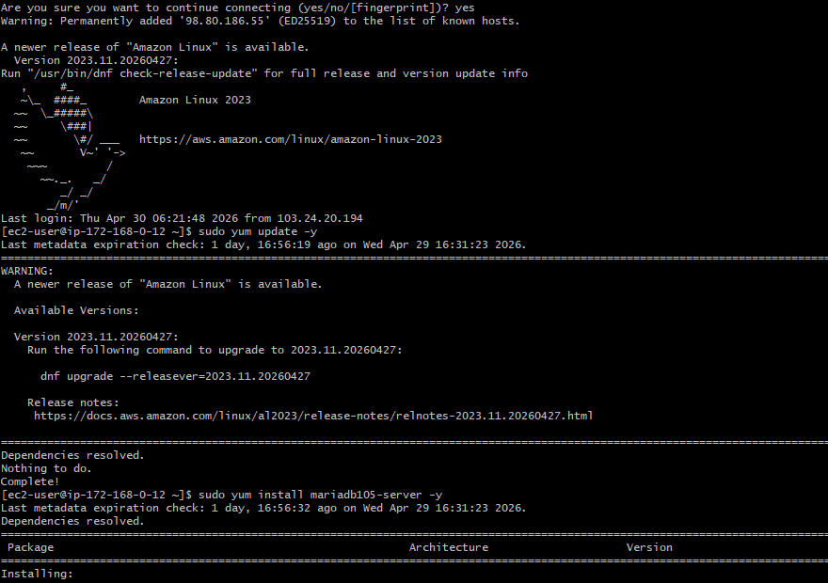 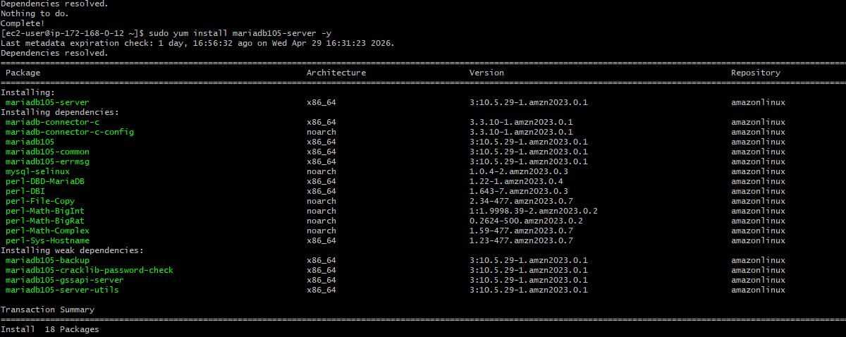 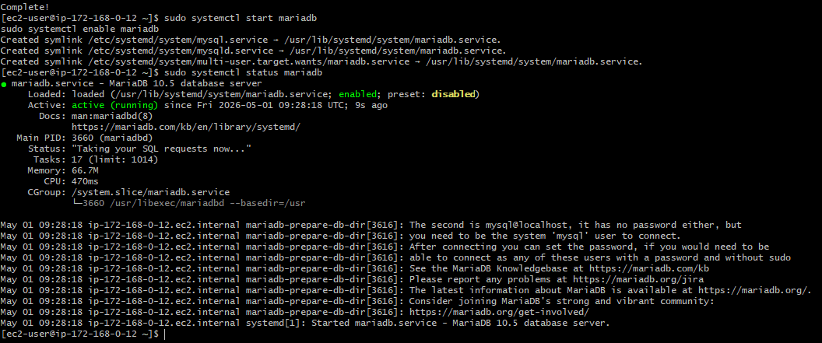
Enter the required details as per your requirement and then hit enter:
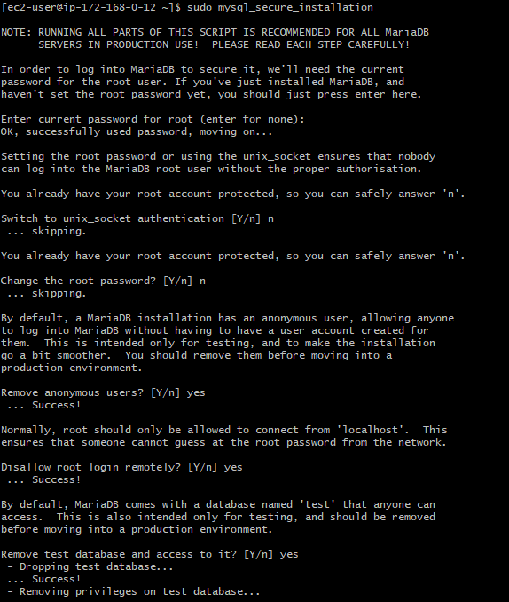

Follow the last four lines as it is while in instance only, no need to connect to mariadb
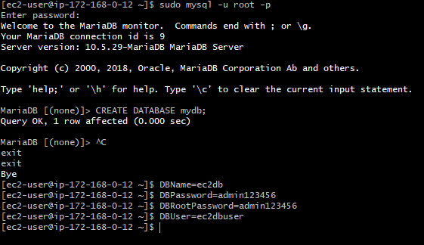
- Insert some dummy data.
From ec2 instance connect to mariadb with mysql -u root -p command and then give your password and then provide the details as per your requirement as shown in the below image:
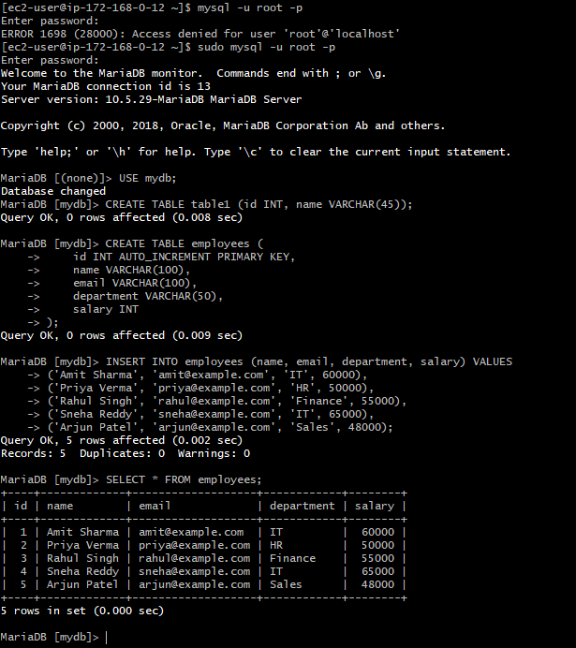
- Take the backup of dummy data on EC2.
Use this command for getting a backup for dummy data on ec2 instance:
mysqldump -u myuser -p mydb > mydb_backup.sql
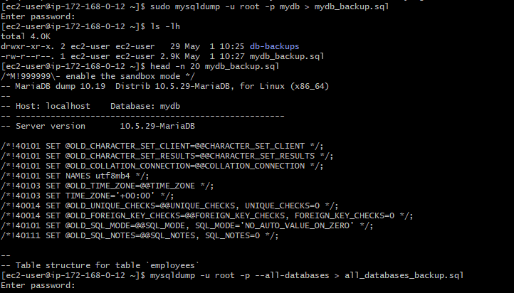
- Launch MariaDB RDS instance.
Created a new database in RDS and then provided required details as shown in the below image:
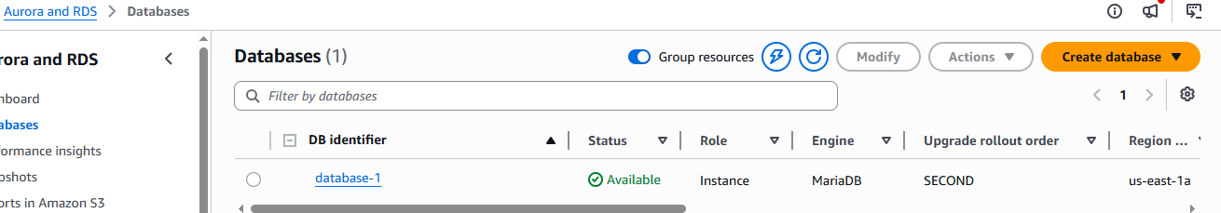 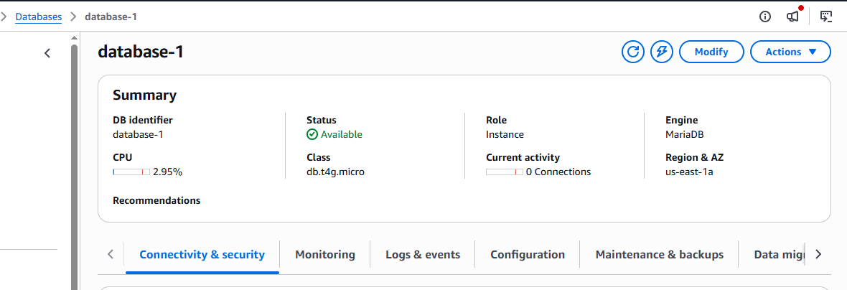 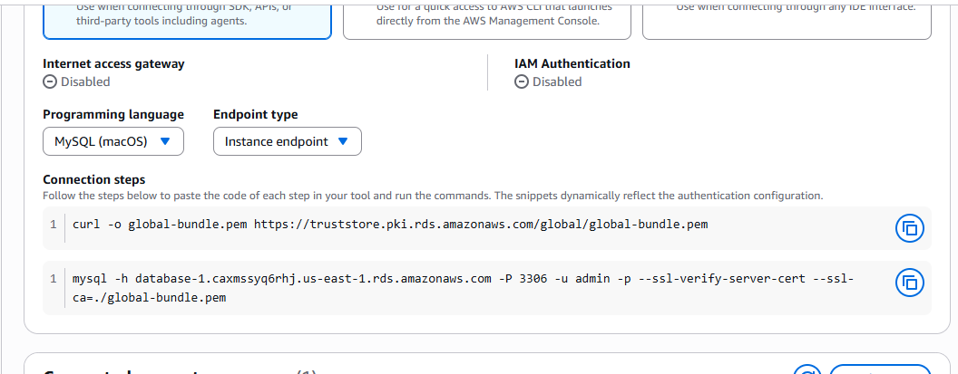 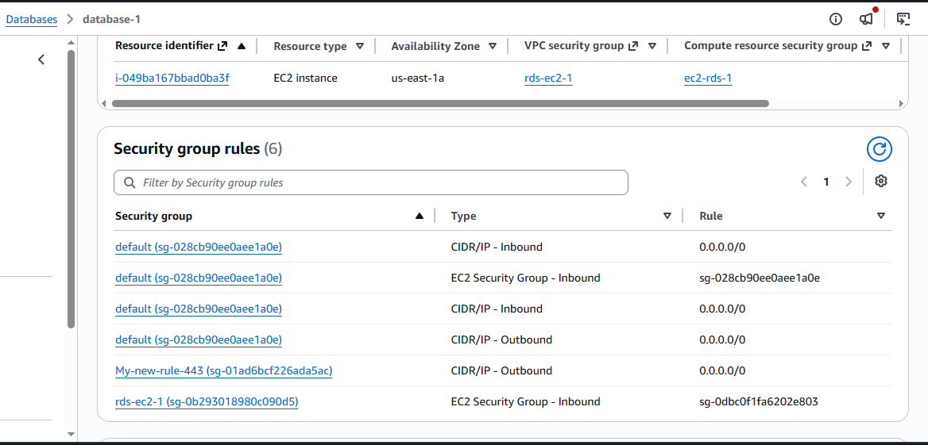
- Migrate database from EC2 to RDS.
Connected to mariadb via start point link and end point link as well: 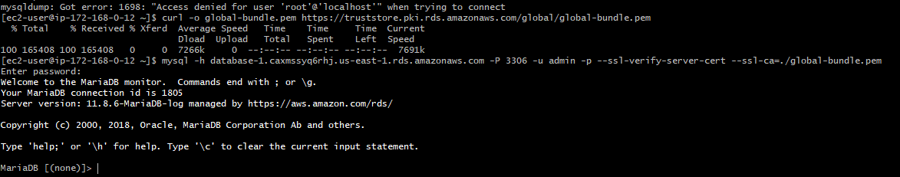 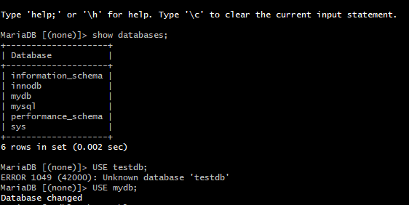
- Install MySQL DB on EC2.
Connected to a new ec2 instance to get mysql installed: 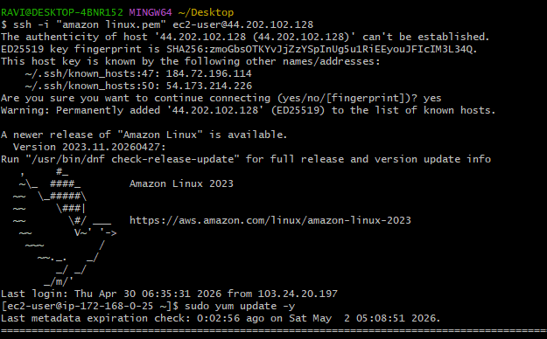
uses 2 diff commands for Mysql downloading and installing shared by bhargav.
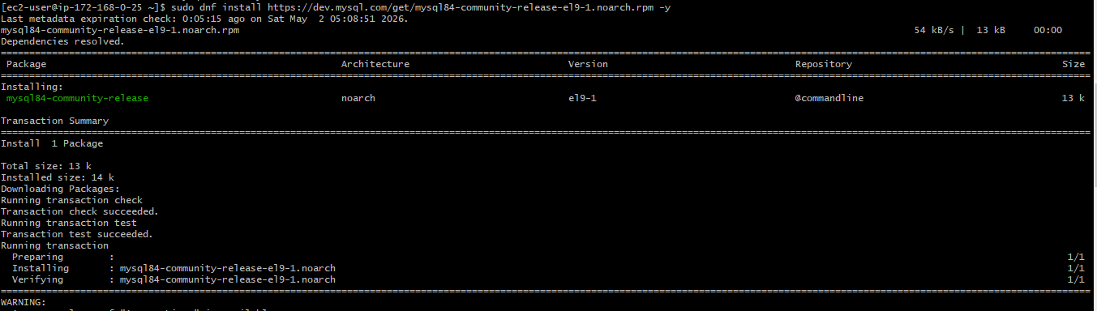 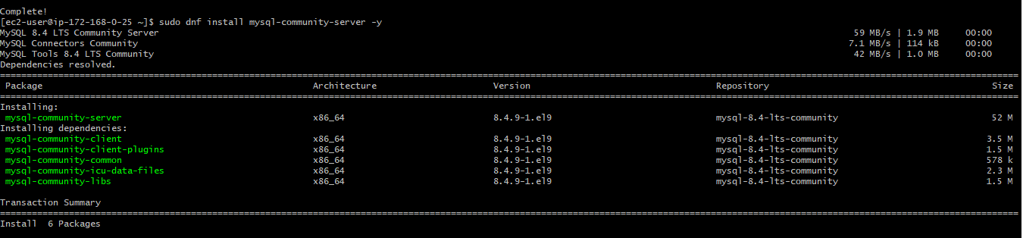 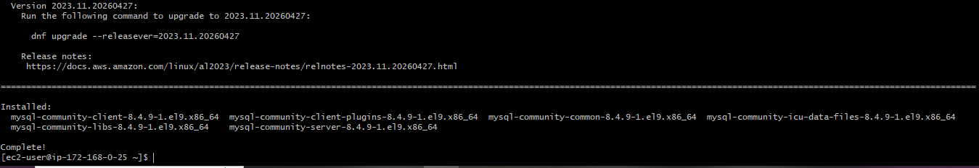
Status check also done
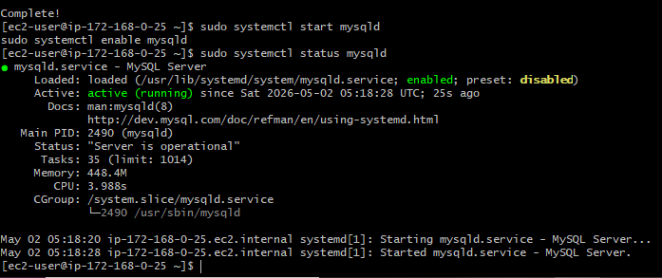
- Launch MySQL RDS image.
Created a new database with the required details as shown in the below image: 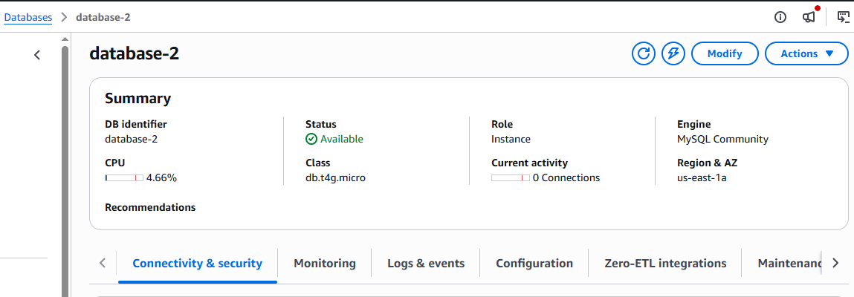
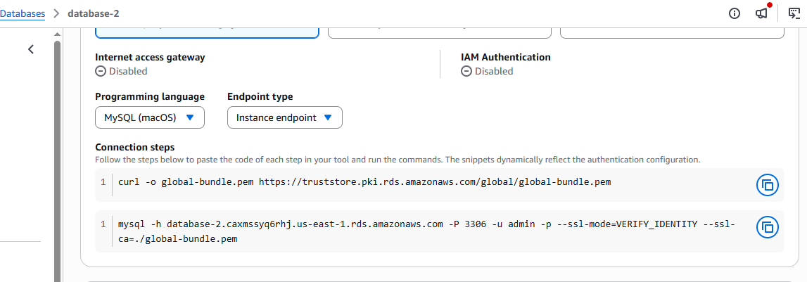 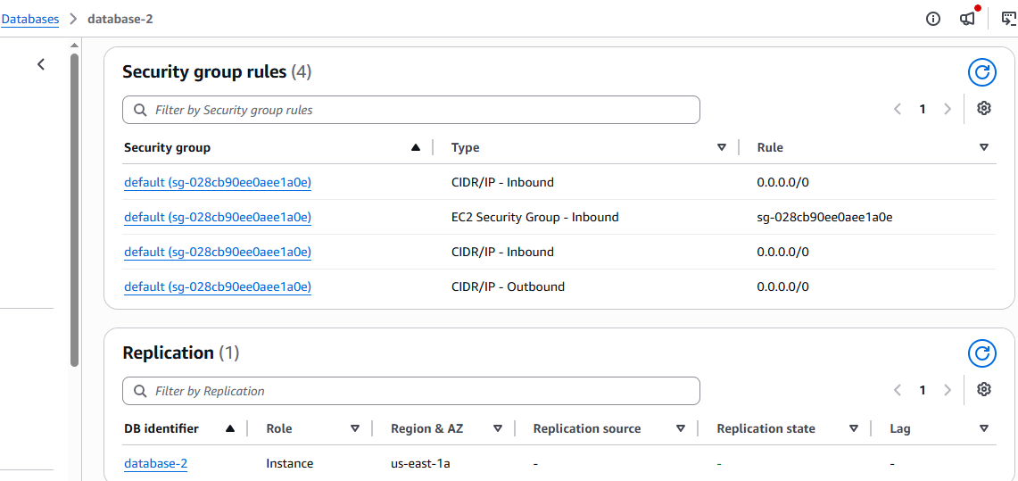
- Configure Multi-AZ.
Unable to process the task because of the free-tire account, it can only be done in via paid account.
- Take backup of DB and restore the DB.
Took the snapshot of DB: 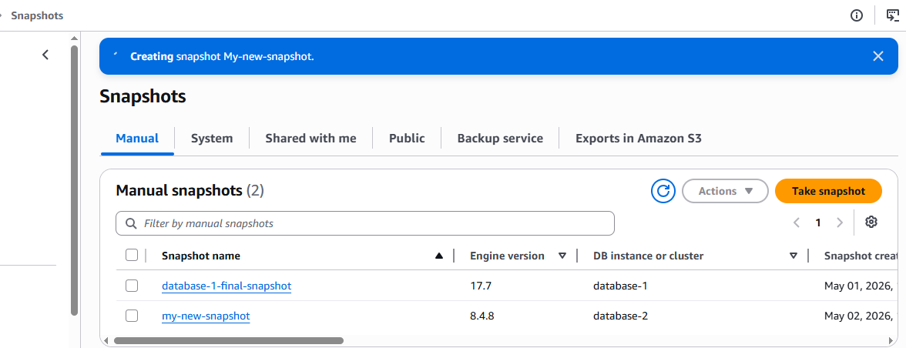 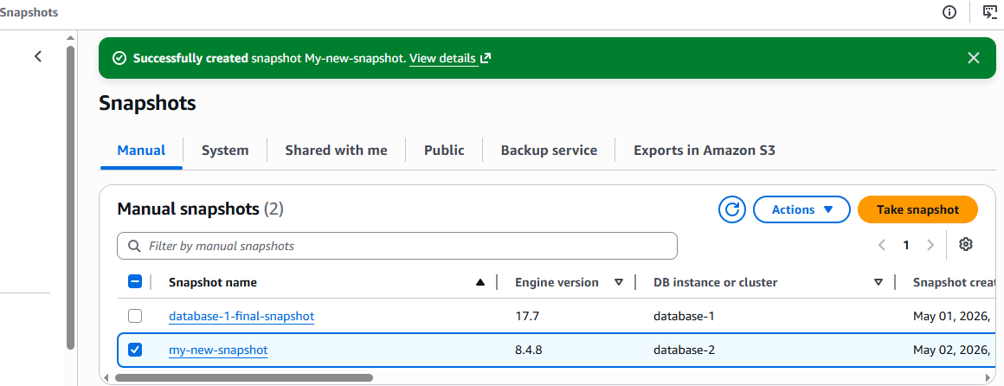
Sucessfully deleted the 2nd database after creating a snapshot and then will try to restore it with the help of snapshot: 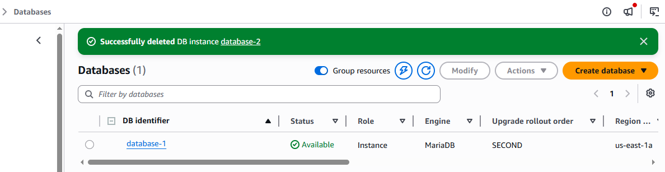
Restoring the database with the help of snapshot with the required details: 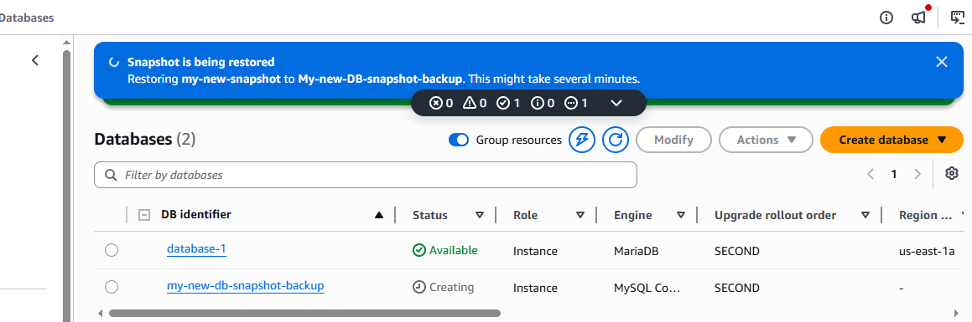
Checked with the ec2 instance as well with the end point if the database is restored or not:
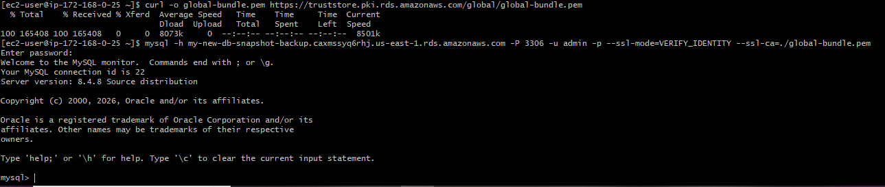
- Create read replica.
Successfully provided the details for read replica but was unable to complete as the error message shows limited access to free account, need to upgrade to paid account.
Followed the below settings as shown in the image:
